**n8n:**

**n8n** is an open-source workflow automation tool that allows users to connect different applications, services, and APIs to automate tasks without writing extensive code. It uses a visual interface where users can create workflows (called "**n8n** workflows") by dragging and dropping nodes (pre-built connectors) to define automation logic.

n8n is **self-hostable**, meaning you can run it on your own server, giving you full control over your data and workflows. It supports integrations with hundreds of apps (like Slack, Google Sheets, Trello, and more) via its extensive node library.

* **Empowering Non-Developers with AI Automation:**
  + You don’t need to know how to code.
* **Access to 400+ Build-in Integrations:**
  + Google apps, Microsoft apps, Slack, X, etc.
  + String them together….infinite possibilities.
* **Connect to Almost Any Tools:**
  + Extend using APIs, Webhooks, and Custom Code.
* **Why do we need “n8n”:**

Manual, repetitive tasks waste time and increase errors. n8n helps by:

* **Automating workflows** (e.g., sending emails when a form is submitted).
* **Integrating apps** (e.g., syncing data between CRM and spreadsheets).
* **Reducing human intervention** (e.g., auto-processing orders from an e-commerce store).
* **Handling complex logic** (e.g., conditional triggers, data transformations).

Unlike paid automation tools (like Zapier or Make), n8n is **free and customizable**, making it ideal for developers and businesses that need flexibility.

* **Example: Automating Lead Management**

**Scenario:**

A company collects leads via a Google Form and wants to:

1. Store responses to Google Sheet.
2. Send a Slack notification to sales team.
3. Add the lead to a CRM (like HubSpot).

**n8n Workflow Steps:**

1. **Trigger:** Google Forms node (detects new form submissions).
2. **Action 1:** Google Sheets node (saves data to a spreadsheet).
3. **Action 2:** Slack node (sends a message to a channel).
4. **Action 3:** HubSpot node (creates a new contact in CRM).

**Visual Workflow:**

Google Form **→** Google Sheets **→** Slack **→** HubSpot

* **Key Benefits of n8n:**

Some key benefits of n8n are:

* **No-Code/Low-Code:** Easy for non-developers.
* **Self-hosted:** Better privacy & control.
* **Extensible:** Supports custom nodes (JavaScript/Python).
* **Cost-Effective:** Free & open-source (unlike Zapier).

**n8n Self-Host vs. Cloud Platform:**

* **Difference between Self-Host and Cloud (n8n.io):**

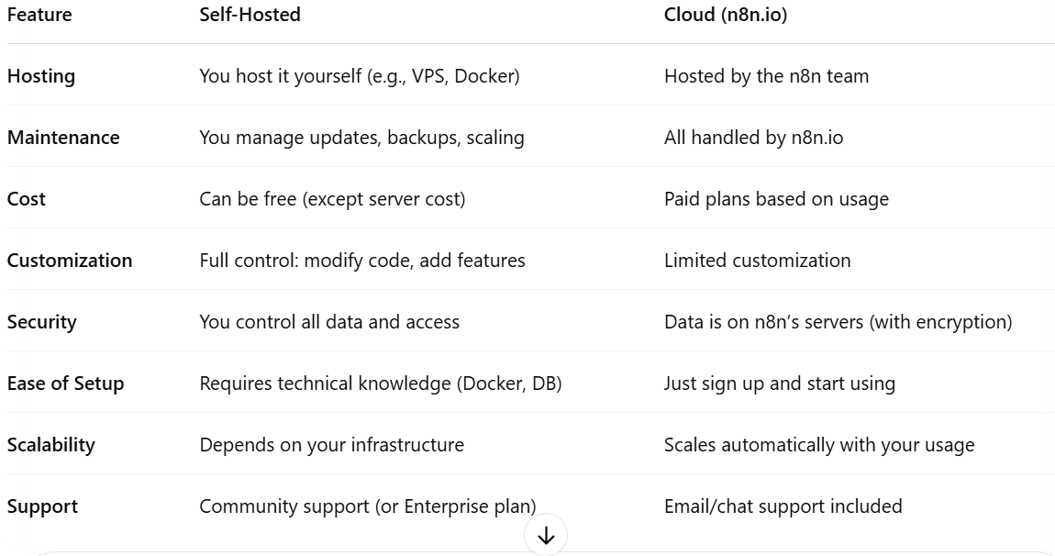

* **How to Choose Self-Host vs. Cloud:**
* **Choose Self-Hosted If:**
* You want **complete control** over your data and environment.
* You need to **customize** n8n (e.g., custom nodes or logic).
* You have the **technical skills** or DevOps team to manage servers.
* You want to **avoid subscription fees** (except for hosting costs).
* You have **compliance requirements** for data privacy.
* **Choose Cloud (n8n.io) If:**
* You want to get started **quickly and easily.**
* You don't want to deal with **infrastructure or updates.**
* You need **reliable uptime and support.**
* You’re okay with storing data on n8n.io’s secure servers.
* You're looking for a **managed SaaS solution** with scaling.
* **Example Scenario:**

Let’s say you're a solo developer building a small app and need to automate a few tasks:

* **Cloud** is ideal—you can set up and run flows in minutes.

But if you're a mid-sized company with sensitive user data and custom logic needs:

* **Self-hosting** makes more sense—you get full control and security.

**n8n Interface:**

Let’s break down the main components of the **n8n interface**—**Workflows**, **Nodes**, and **Executions**—with an easy-to-understand example.

1. **Workflow:**

A **workflow** is the complete **automation logic** built visually inside **n8n**. It connects multiple apps or services (via **nodes**) to perform tasks in sequence or conditionally.

* 📌 Think of a workflow like a **flowchart:**

It starts with a **trigger** (like a form submission) and flows through different **actions** (send email, save to database, post to Slack, etc.).

* **Example Workflow:**

**Goal:** When a user fills out a contact form (via Typeform),

* Save the info to **Google Sheets,**
* Send a **Slack alert** to the team,
* And email a **thank-you message** via **Gmail.**

This complete logic is one **workflow** in n8n.

1. **Nodes:**

Nodes are the **building blocks** of a workflow. Each **node** performs a specific task—like triggering the workflow, processing data, or integrating with an external app.

* **Types of Nodes:**
* **Trigger Node**: Starts the workflow (e.g., Webhook, Form, and Cron).
* **Action Node**: Does something (e.g., Send Email, Add Row to Google Sheet).
* **Logic Node**: Adds decision-making (e.g., IF, Switch, Merge).
* **Example from above:**

|  |  |
| --- | --- |
| **None Type** | **Description** |
| Trigger | Typeform Node (starts when form submitted). |
| Action | Google Sheets Node (adds data). |
| Action | Slack Node (sends a message). |
| Action | Gmail Node (sends thank-you email). |

1. **Execution:**

An **execution** is what happens when a workflow **actually runs**.  
Each time a trigger fires (e.g., someone fills the form), a **new execution** starts and moves through the nodes.

* **Execution Details:**
* You can **view past executions** to see what happened, what data was passed, and whether any errors occurred.
* Helps in **debugging** and **monitoring** your automation.
* **Example:**

If 5 users submit your form today, there will be **5 separate executions** of your workflow, each one logging how the automation ran for that user’s data.

**Types of Nodes in n8n:**

Let's dive into the **different types of nodes in n8n**, what they do, and how they're used — with examples to make things clear. Nodes are the **heart** of any workflow in n8n, and each one has a specific role.

* **Types of Nodes in n8n:**

n8n nodes can be broadly categorized into **5 main types**:

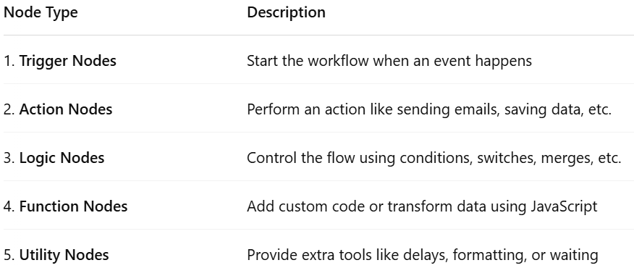

* **Explore all the Nodes in n8n:**

Let’s explore all the Nodes:

1. **Trigger Nodes:**

These **start** the workflow when something happens. They "listen" for events.

* **Example:**
  + **Webhook**: Starts when data is sent to a specific URL.
  + **Schedule (Cron)**: Runs the workflow at scheduled times.
  + **App Triggers**: Like **Gmail Trigger** (on new email), or **Typeform Trigger** (on form submission).
* **Use Case:**

Start a workflow every day at 9 AM to send daily reports → Use a **Cron Trigger.**

1. **Action Nodes:**

These nodes **do something**—send messages, update a database, call an API, etc.

* **Example:**
  + **Gmail**: Send an email.
  + **Slack**: Send a message to a channel.
  + **Google Sheets**: Add or update rows.
  + **HTTP Request**: Call external APIs.
* **Use Case:**

After a user submits a form, **send a thank-you email via Gmail** → Use the **Gmail node.**

1. **Logic Nodes:**

These nodes help control the **decision-making and flow** of data in a workflow.

* **Example:**
  + **IF Node**: Runs different paths depending on conditions.
  + **Switch Node**: Routes data based on values (like a switch-case).
  + **Merge Node**: Combines data from two branches.
* **Use Cases:**

If the user's role is "admin", send an alert; otherwise, just store the data → Use the **IF node.**

1. **Function Nodes:**

These allow you to **write JavaScript** to manipulate data.

* **Example:**
  + **Function**: Write custom code to change or filter incoming data.
  + **Function Item**: Works on each item in a list separately.
* **Use Case:** You want to **capitalize a user's name** before sending an email → Use a **Function node** to edit the name.

1. **Utility Nodes:**

These help manage timing, formatting, waiting, or simplifying data.

* **Example:**
* **Wait**: Pause the flow for a set time.
* **Set**: Set new fields or values.
* **Date & Time**: Format or shift dates.
* **Use Case:**

After user registration, **wait 5 minutes**, then send a follow-up email → Use the **Wait node.**

* **Example: Lead Capture Automation**

**Goal**: A user fills out a Typeform. Based on their role, either send an email or store their data.

**Workflow with Node Types:**

